PROJECT- 1

**Serverless Image Processing**

Creating a serverless image processing application that resizes and optimizes images uploaded to an Amazon S3 bucket involves several steps.We’ll use AWS service such as S3,Lambda, and CloudWatch.

##Table Of Contents

1)Introduction

2)Dataflow Diagram

Created by- Teena Dixit

3)Prerequisties

4)Step-By-Step Guide

5)Conclusion

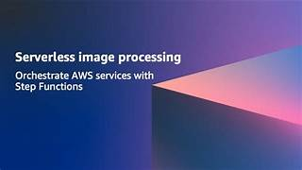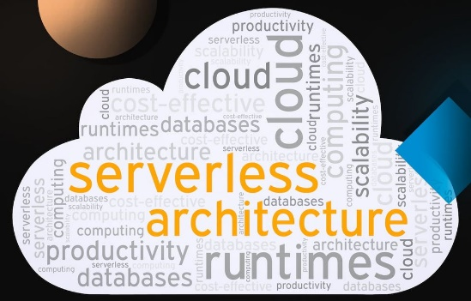

1. Introduction

Image procesing is a crucial part of modern tecnology, and aws has revolutionized how it can be done. In this presentation,will explore the many ways AWS can be used for image processing, including image recognition, analysis and transformation.

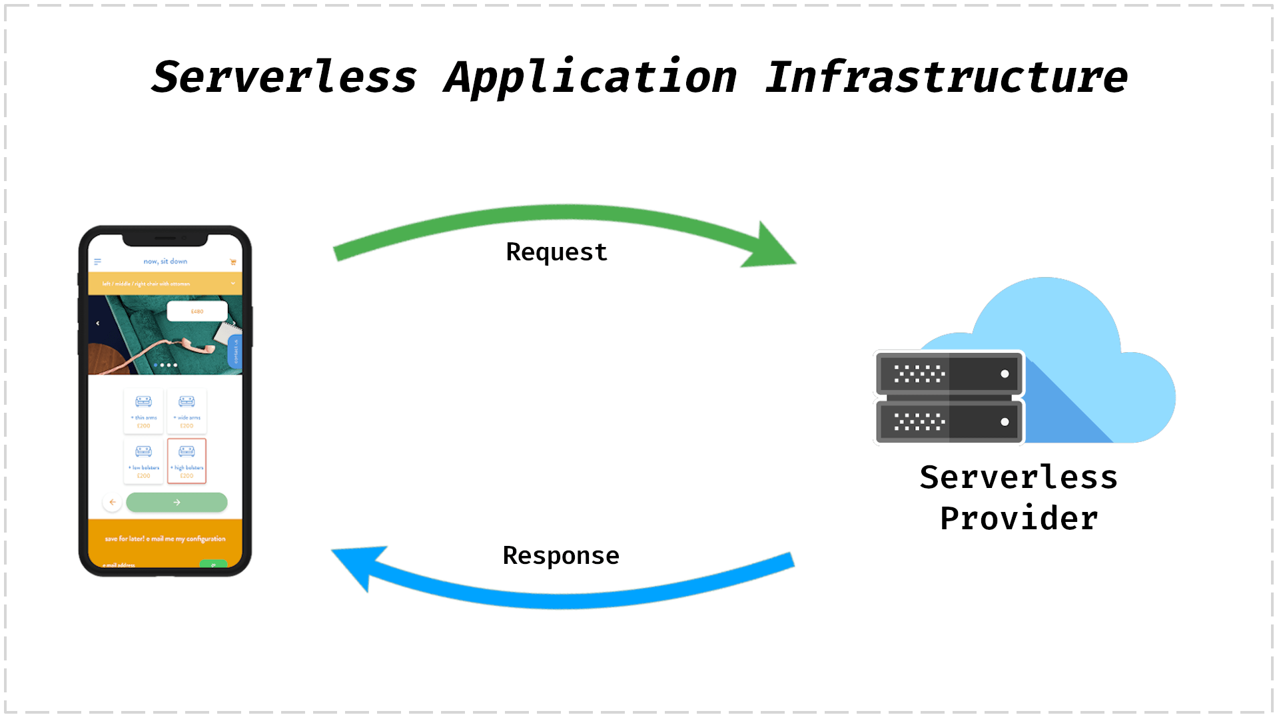

2)Dataflow Diagram

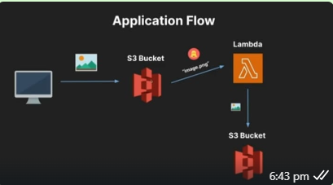

3)Prerequisties

1. **Aws Account**:-

-Ensure you have an AWS account.

2)**IAM Role:-**

-Create an IAM role for Lambda with the necessary permissions to access S3 and write logs to CloudWatch.

4)Step by Step

**1)Create an S3 Bucket:-**

-Set up two S3 bucket .One is the source bucket where we upload the image and another destination bucket where the image get resized.

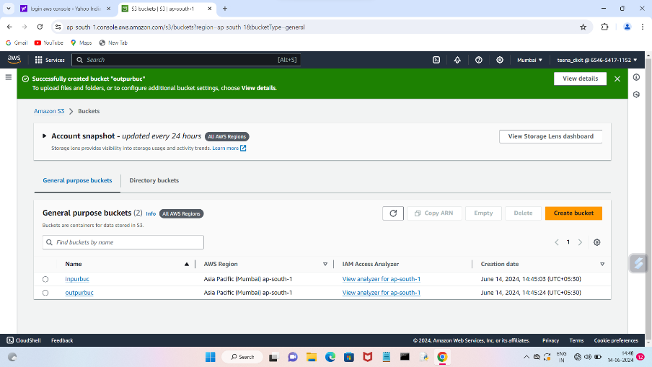

**2)Upload Image**

**-**we need to upload the image in our source bucket.

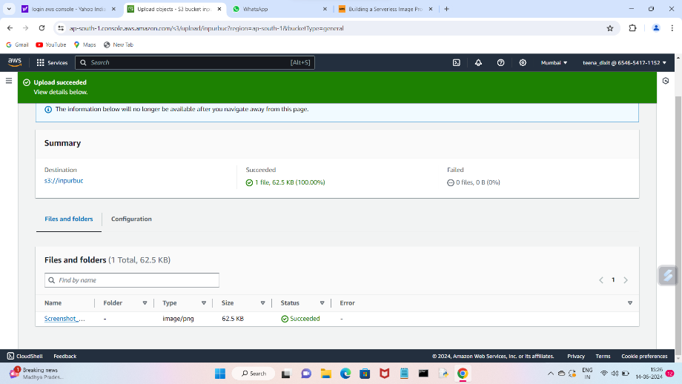

**3)Create IAM Policy**

-We need to specify the json policy editor and give suitable name to the policy.

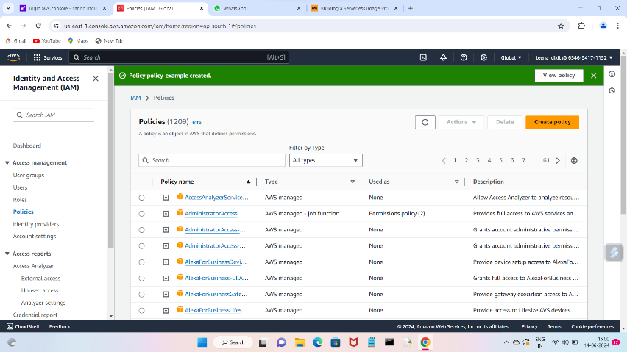

**4)Create IAM Role**

**-**we need to define IAM role.We need to add permissions policies which we have created.

-Give suitable name to the role and create role.

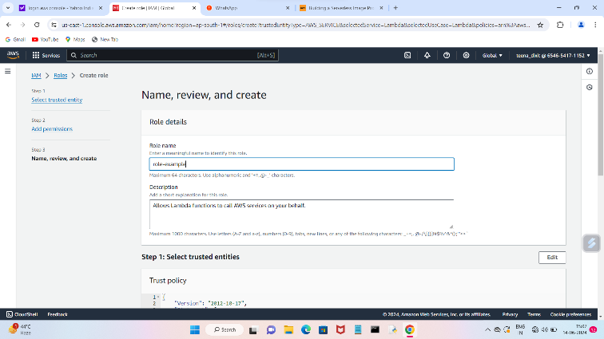

**5) Create Lambda Function:-**

-Go to the Lambda service in tha AWS console.

-Create a new function, choose Author from scratch.

-Choose the runtime(eg Nodejs 18x).

-Choose the runtime(eg Nodejs 18x).

-Assign the IAM role created earlier with permissions to access S3 and CloudWatch.

-Assign the IAM role created earlier with permissions to access S3 and CloudWatch

**6)Add Trigger**

**-**In the trigger we need to add S3 bucket.

-In S3 bucket we add our source bucket rest all setting will remain same.And then add.

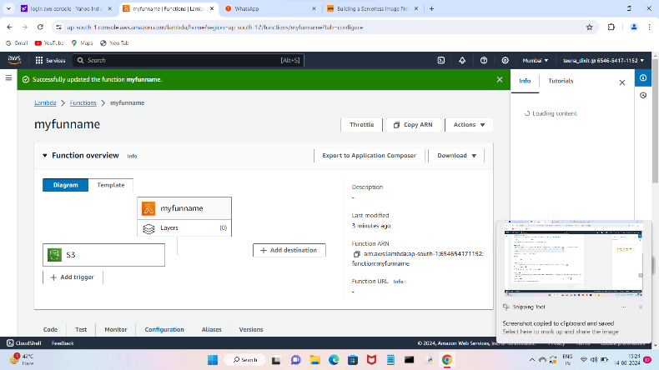

**7)Environment Variables**

**-** There we need to create a key for eg(DEST_BUCKET) and Value for eg(my destinationbuck)

**8) Upload A Zip File**

-We need to upload a zip file and save it.

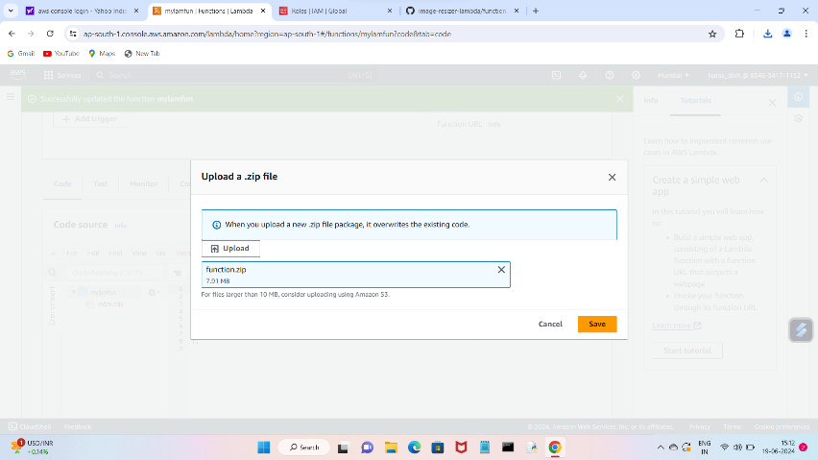

**9) Deploy and Test**

-Deploy the Lambda function if not done already.

-Upload an image to S3 bucket.

-Check the S3 bucket to ensure the resized image appears in the resized folder.

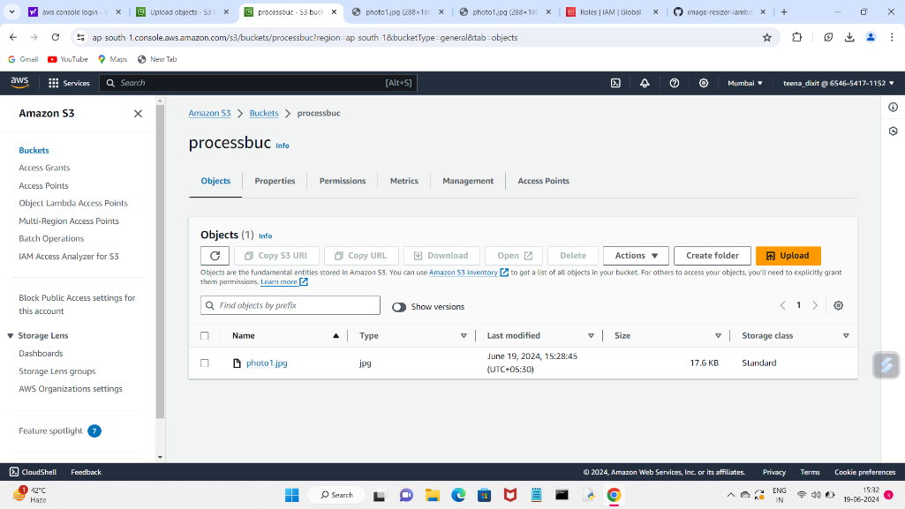 5) Conclusion

This setup will automatically resize and optimize any image uploaded to the S3 bucket, leveraging AWS Lambda for serverless processing.

